Matthew Prescher

80592956

September 10, 2019

Lab 1 Option A

**Introduction:**

The given code is able to take a reddit comments section, make a list of them along with the replies. In addition to this the code can also return whether it is a positive, negative or neutral. The task presented to us is to add a function that will take a comment as a parameter, go through its replies as well as any other replies present, deciding whether they are positive, negative or neutral. Once that is done the replies are placed into a list for one of the corresponding types: positive, negative, neutral.

**Proposed Solution:**

The requirement of this lab is that we solve the task given using recursion, meaning the use of a for loop or while loop is prohibited. The first step is to take in the first comment that is present in the in the list of comments. Afterwards, given the comment access its replies and rate them into a category. Once rated add them to a list the will contain the same category of replies. This process is to be repeated for every reply and the replies of those replies, until there are no replies to go through. Finally, the function will return the list of all three categories of replies.

**Experimental results**:

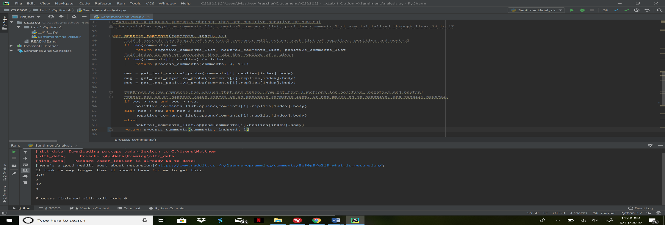 At the first attempt to complete the function to go through the replies and rate them, I was only getting a total of 57 total replies being read and inserted into their respective list. This can be seen below.

However, in the following attempt, as well as the final implementation of the code, the length of the lists were exceptionally different, except for that of the negative list, which was unchanged from the original value of 2. This was fixed by adding another recursive call in line 59. This change can be seen in the final form of the code, in the appendix section.

**Conclusion:**

The most important coding skills I have learned from this project is a better use of recursion, as well as the testing of given code in order to better understand said code. My use and understanding of list has increased as well, the ability to append to a list even in a recursive function is one that I did not have before.

**Appendix:**

